

Practices for Secure Software Report

Table of Contents
Document Revision History 3
Client 3
Instructions 3
Developer 4
1. Algorithm Cipher 4
2. Certificate Generation 4
3. Deploy Cipher 4
4. Secure Communications 4
5. Secondary Testing 4
6. Functional Testing 4
7. Summary 4
8. Industry Standard Best Practices 4

Document Revision History

Version | Date | Author | Comments
1.0 | 08/10/2026 | Makenzie VanAusdall | Cipher, Certificates and Checksum
1.0 | 08/11/2026 | Makenzie VanAusdall | Secure communications, secondary testing, functional testing
1.0 | 8/14/2026 | Makenzie VanAusdall | Summary, Best practices

Client



Instructions

Submit this completed practices for secure software report. Replace the bracketed text with the relevant information. You must document your process for writing secure communications and refactoring code that complies with software security testing protocols.

- Respond to the steps outlined below and include your findings.
- Respond using your own words. You may also choose to include images or supporting materials. If you include them, make certain to insert them in all the relevant locations in the document.
- Refer to the Project Two Guidelines and Rubric for more detailed instructions about each section of the template.

Developer
Makenzie VanAusdall

Algorithm Cipher

The cipher algorithm I would recommend for Artemis Financial’s project would be Advanced Encryption Standard (AES) with a 256-bit key. AES is a good choice because it is the global cryptographic standard, so this will be feasible to use with Artemis’ international clients, and it is also supported by various software and hardware. The 256-bit key option will prevent an attacker brute forcing their way through, as it would take an unreasonable amount of time to try every possibility to crack the key. AES-256 will also be good for symmetric cryptography, where “a secret key is used to “scramble” information in a way that is virtually impossible to unscramble without the secret key. This type of cryptography is called symmetric because the same key is used for both encrypting and decrypting the data” (Manico & Detlefsen).
A downside to using AES-256 is there is a chance Java is too outdated to run it efficiently, in which case you could move down to AES-128, which isn’t quite as secure but is still better than the old standard DES. There is also great vulnerability in the cipher key itself; it needs to be kept secure otherwise the encryption means nothing, you need the key to encrypt and decrypt. Following this path is compliant with Gramm-Leach-Bliley Act since we are aiming to use the highest standard for encryption possible, so for this project I would say AES-256 is the best cipher to use for the reason listed above. If I had to choose any other, it would be AES-128 and that would only be if our JRE or other working components aren’t compatible with 256-bit encryption.
The justification for these decisions is mainly due to AES being a symmetric key, which makes it a faster option for large data files, and the bit level also notes the maximum number of combinations available, the higher the bit level, the more possible combinations someone would have to go through before they could “brute force” your key. Randomization of numbers in a cryptographic key further assists in making the cipher difficult to crack or access, “A cryptographic pseudorandom number generator (CPRNG) minimizes this issue by algorithmically generating data that appears to be random” (Manico & Detlefsen). The final justification is the nature of AES in general being such a widely supported tool among multiple software and hardware options, so widely supported that “implementers may choose to design their AES implementations with future flexibility in mind” (FIPS 197). As mentioned before, Data Encryption Standard (DES) used to be the go-to cipher until it was replaced by AES. DES had less options in key length and had smaller block size. As technology stared pacing forward faster, there needed to be a new standard that could be widely compatible with current (and future) systems, this is where AES was introduced; compatible with key lengths of 128-bit, 192-bit or 256-bit to be able to use a method that works for your system, faster processing speed , and the fact that is could be widely adopted in many instances made it candidate number one to become the new gold standard, and it is still easy to see why that applies today.

Sources cited:
FIPS 197, Advanced Encryption Standard (AES). csrc.nist.gov. (n.d.). https://csrc.nist.gov/files/pubs/fips/197/final/docs/fips-197.pdf
Manico, J., & Detlefsen, A. (n.d.). Chapter 6: Protecting Sensitive Data. essay, McGraw Hill Education. Retrieved July 2026, from https://learning.oreilly.com/library/view/iron-clad-java/9780071835886/title.html.

Certificate Generation
Insert a screenshot below of the CER file.

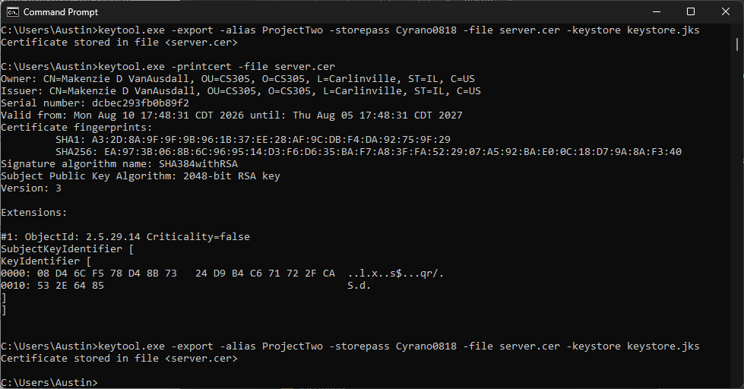

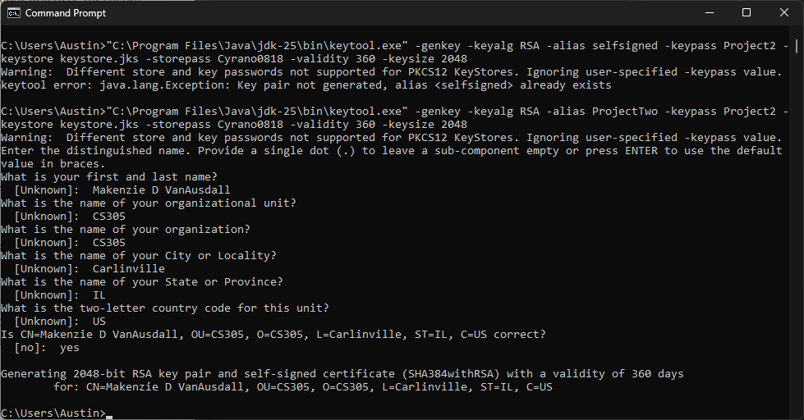

Deploy Cipher
Insert a screenshot below of the checksum verification.



Secure Communications
Insert a screenshot below of the web browser that shows a secure webpage.



Secondary Testing
Insert screenshots below of the refactored code executed without errors and the dependency-check report.

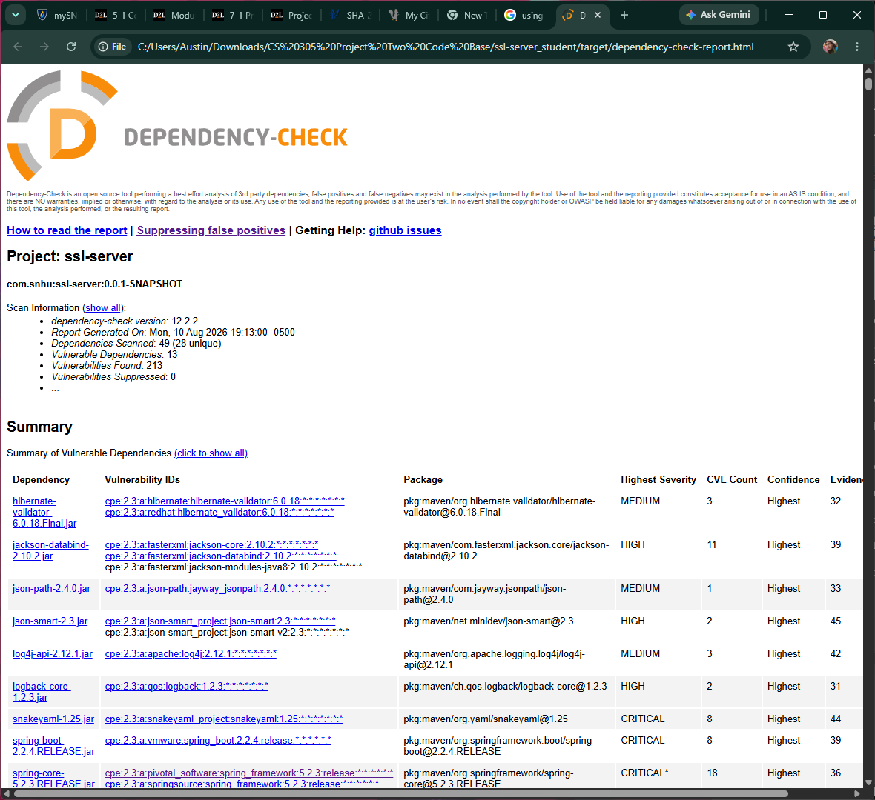

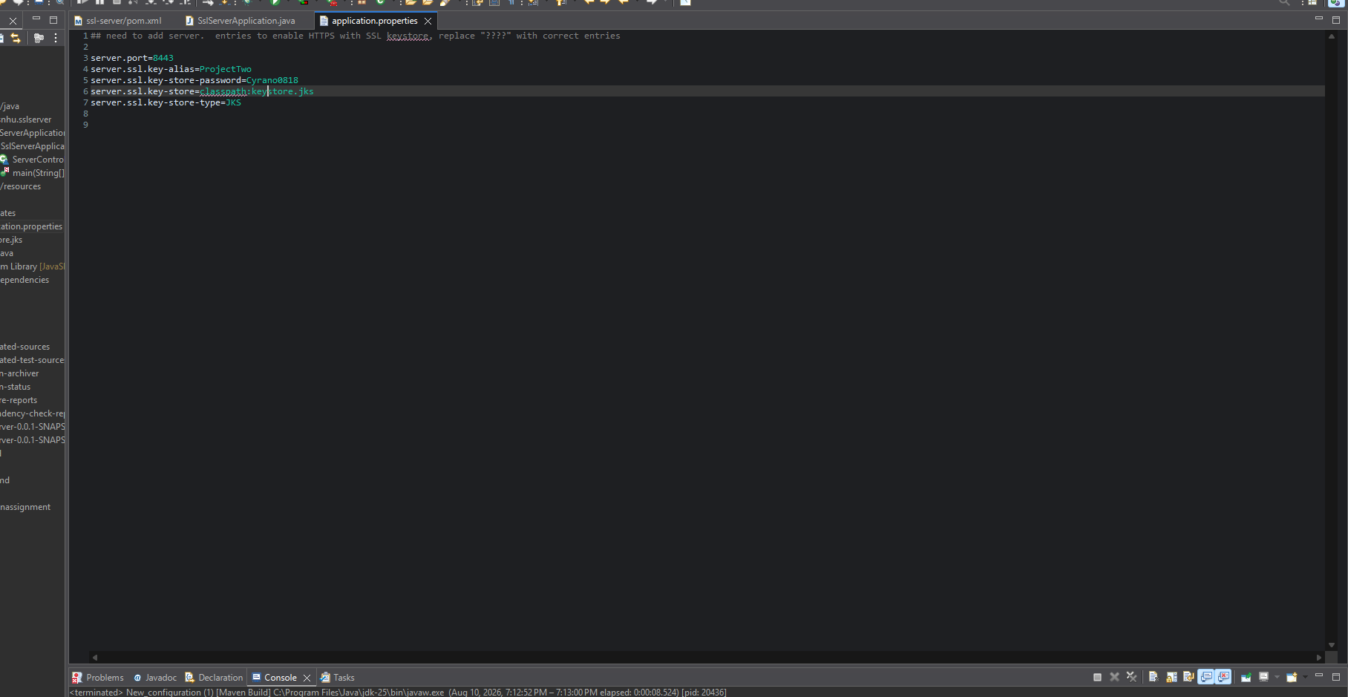
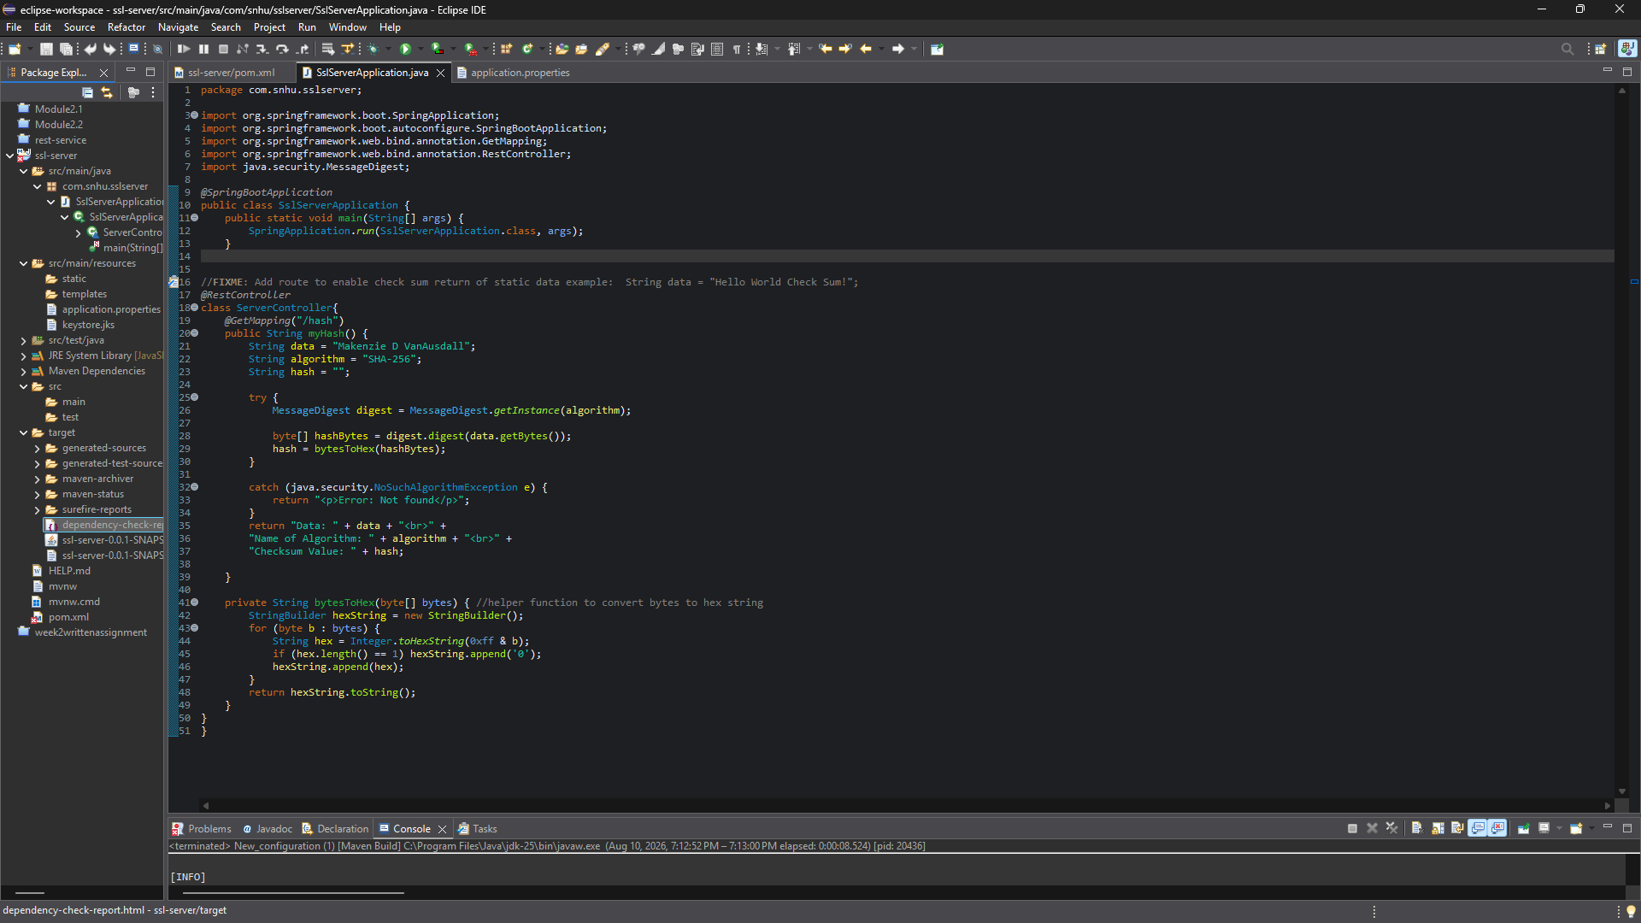

Functional Testing
Insert a screenshot below of the refactored code executed without errors.

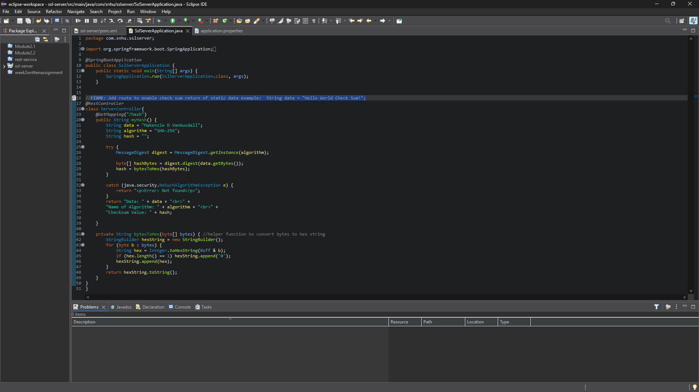

Summary

The main area addressed by my refactoring of the code was the application cryptography. Adding in a hash algorithm prevents collisions, which can happen with outdated cryptography and leave a program prone to checks being bypassed or data forgery. Here, I used SHA-256, which is an improvement over what was previously implemented and ensures unique data signature generation. There was also implementation of a RestController to set a designated API route with an explicit endpoint. This assists in allowing the data to be encrypted in transit over HTTPS instead of HTTP, preventing sensitive data from being viewed or accessed while in transit.
I also added error handling to give back a standard message, instead of an unknown element that could possibly contain sensitive information. This was able to be done using a targeted catch block. There was also data formatting implemented with the bytestohex function which also helps with validation checks. This function does so by formatting bytes into a hexadecimal format before it is displayed, also removing dangerous characters or content in the process.
The main idea when adding security to Artemis Fiancial’s application was to improve upon, and not rebuild. The existing structure of the program should remain intact, so it was best to implement security measures that can be used with existing libraries, which was done using Java libraries such as MessageDigest. Anything that added an additional vulnerability to the program was excluded or reworked to ensure that what was added would only benefit the program.

Industry Standard Best Practices

As mentioned above, there was a focus on adding to the program to make it better instead of rewriting everything completely but still making it up to par with the kind of program Artemi Financial needs. Adding API endpoints, secure data transit, and cryptography algorithms have made the sensitive data Artemis deals with more secure and less prone to leaks, and unauthorized access. These changes are compliant with all GLBA regulations and are made to mitigate risks involved with unsecure data. This also preserves Artemis Financial as a trustworthy company in the eyes of clients and is cost effective when compared to what would be spent to fix these mistakes once they have happened.
I would consider the code used modular and reusable, as I pulled my code from a previous assignment to work with, there are proper closed loops and error/exception handling, and no new vulnerabilities were introduced to the program through my code. If anything, I seemed to notice that my code being implemented helped fix cryptography flags that previously had been littered throughout the dependency check report. Utilizing proper OOP principles help ensure secure code, which make up secure applications. Over time while the company is in business, having secure applications ensures the client-base trusts Artemis Financial as they handle money and personal information, and doing so is also good for Artemis’ representation as being trusted and spoken highly of your client base is likely to attract new business.

